Year  7 |  | Data Collection and Representation | Non Calculator  Section
Skills and Knowledge Assessed:  - Investigate techniques for collecting data, including census, sampling and observation (ACMSP284)  - Explore the practicalities and implications of obtaining data through sampling using a variety of investigative processes (ACMSP206)  - Identify and investigate issues involving numerical data collected from primary and secondary sources (ACMSP169)  - Construct and compare a range of data displays including stem- and - leaf plots and dot plots (ACMSP170) |  |  | Name___________________
Answer all questions in the spaces provided on this test paper by:
Writing the answer in the box provided.
or
Shading in the bubble for the correct answer from the four choices provided.
Show any working out on the test paper. Calculators are not allowed.
Raj asks every third person in his scout troupe to write down their age on a piece of paper, which he collects and records.

He is:

Collecting data by taking a census of the troupe.

Collecting data by taking a sample of the troupe.

Collecting data by observation.

Collecting data by measurement.

Jordan does a survey by asking his classmates what brand of smart phone they use.

This is an example of:

Categorical Data. Continuous Numerical Data.

Discrete Numerical Data. Observed Data.

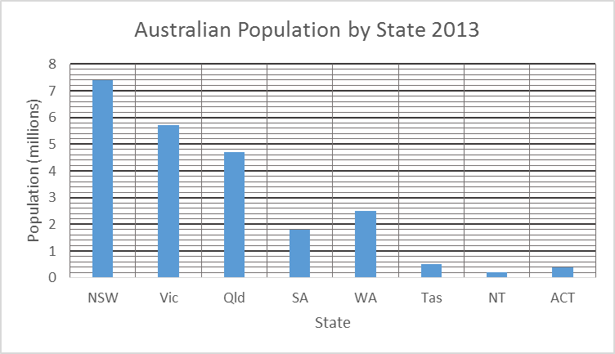

Questions 3 – 6 refer to the graph above.
What was the population of Victoria in 2013?

57 000 570 000 5 700 000 57 000 000

 | Which State had a population of two and a half million people in 2013?
Which state had the smallest population?

(NB. NT and ACT are not states.)

Which state had a population about of that of NSW?

Qld. SA. Vic. WA.

Nikita draws a line graph showing the room temperature over a period of 6 hours.

This is an example of:

Categorical Data. Continuous Numerical Data.

Discrete Numerical Data. Observed Data.

Number of Books Read in the Last 6 Months from a Sample of People

 |  |  |  |  |  |  |  |  | Ο
 |  |  |  | Ο |  |  |  |  | Ο | Ο
 |  | Ο |  | Ο |  |  |  | Ο | Ο | Ο
 |  | Ο | Ο | Ο | Ο |  | Ο | Ο | Ο | Ο
 | Ο | Ο | Ο | Ο | Ο |  | Ο | Ο | Ο | Ο
Ο | Ο | Ο | Ο | Ο | Ο | Ο | Ο | Ο | Ο | Ο
Ο | Ο | Ο | Ο | Ο | Ο | Ο | Ο | Ο | Ο | Ο
0 | 1 | 2 | 3 | 4 | 5 | 6 | 7 | 8 | 9 | 10 or more
 |  |  | Number of Books

Questions 8 – 11 refer to the dot plot above.
How many people read 4 books?

6 7 8 9

 | How many people read 8 books or more?
How many people were included in the sample?

7 10 46 48

Zahra was included in the survey. She looked at the results and said:

"There were four others who read the same number of books as I did".

How many books did Zahra read?

Either 2 or 8. Either 2 or 10. Either 4 or 8. Either 4 or 10.

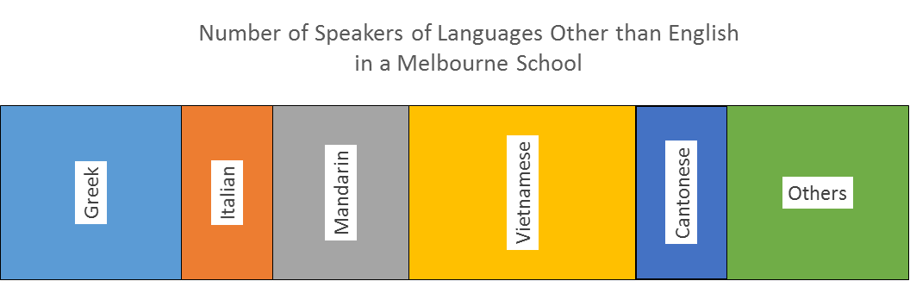

Questions 12 – 15 refer to the graph above. (Use a ruler to assist with your answers.)
Which language made up about a quarter of the speakers?

Cantonese Greek Mandarin Vietnamese

 | Which language had the same number of speakers as Cantonese?
 | Greek was spoken by what fraction of the speakers?
 | What percentage of the speakers spoke Mandarin (nearest whole percent)?
There were 400 speakers of Languages other than English at the school.

How many spoke Greek?

Year  7 |  | Data Collection and Representation | Calculator Allowed  Short Answer  Section
 |  |  | Name___________________
Answer all questions in the spaces provided on this test paper by:
Writing the answer in the box provided.
or
Shading in the bubble for the correct answer from the four choices provided.
Show any working out on the test paper. Calculators are allowed.
Which of the following is an example of using observation as a data collection method?

A company asks all of its shareholders fill in a voting form to decide on a proposal.

A doctor measures the mass of all of his patients.

A magazine rings every person on its subscribers list.

A researcher counts how many people passing his office are wearing a tie.

Shreya asked her classmates their favourite recording artist.

Which of these graphs would not be appropriate to represent this data?

Column Graph. Divided bar Graph.

Line Graph. Sector Graph.

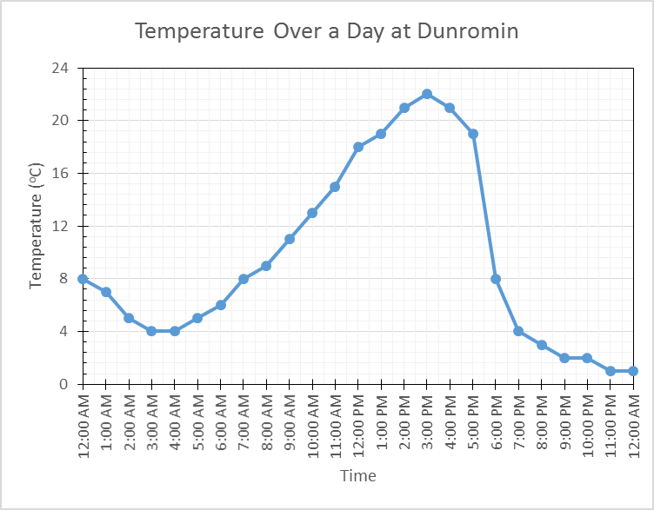

Questions 3 – 6 refer to the graph above.
What is the temperature at 6 pm?

º C

At what times is the temperature 19ºC?

1 am and 5 pm 1 pm and 4 pm 1 pm and 5 pm 2 pm and 5 pm

The temperature range is the difference between the maximum and minimum temperatures.
What is the temperature range for the day?

During the day a cold change came through Dunromin, and the temperatures dropped suddenly.

Between what times did the cold change arrive?

2 pm and 3 pm 3 pm and 4 pm 4 pm and 5 pm 5 pm and 6 pm

Which of the following is an example of obtaining an unbiased random sample of employees from an engineering business which employs 450 people?

Choosing every fifth male in the welding section.

Choosing every fifth employee in the welding section.

Choosing every fifth male and every fifth female employee from each section of the company.

Choosing every fifth employee from each section of the company.

Runs Scored by members of a T20 Cricket Team

Stem | Leaf
0 | 3 | 4 | 5 | 6 | 8
1 | 3 | 4 | 5 | 6 | 7 | 9
2 | 0 | 0 | 3 | 3 | 7 | 8 | 9
3 | 6 | 8 | 9 | 9
4 | 0 | 0 | 0 | 5 | 7
5 | 0 | 5 | 7
6 | 3

Questions 8 – 11 refer to the graph above.
What score was most common? (i.e. scored more times than any other score)

How many scores were 40 or more?

4 6 8 9

How many times was 20 runs scored?

What is the difference between the highest and lowest scores?

60 61 62 63

A manufacturer wants to find out what customers think of its new product.

Which of these surveys uses a biased sample to collect the information?

The manufacturer rings every 20th customer on an alphabetical list.

The manufacturer posts a survey form to every 10th customer on an alphabetical list.

The manufacturer posts a survey form to every customer who lives in a certain suburb.

The manufacturer rings all customers who have a vowel as the first letter of their name.

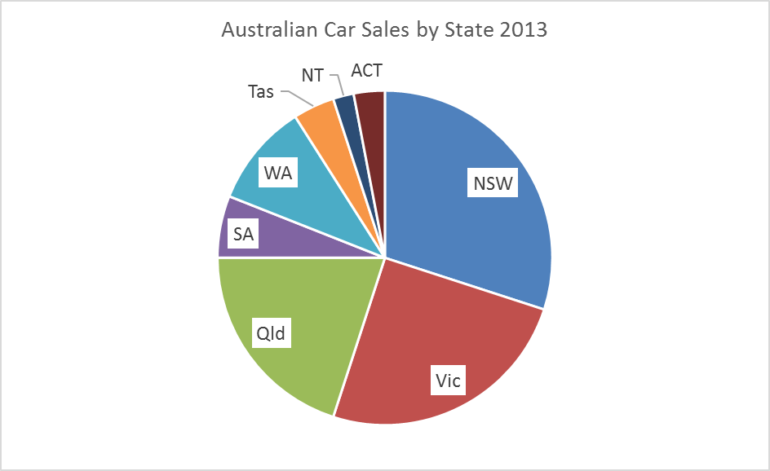
Questions 13 – 16 refer to the graph above. (Use a protractor)
What fraction of car sales were from Victoria?

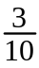

What percentage of sales were from NSW?

%

There were 1.2 million cars sold in Australia in 2013.

How many were sold in Qld?

120 000 240 000 360 000 480 000

How many more cars were sold in Qld compared to WA?

cars.

Year  7 | Data Collection and Representation | Calculator Allowed  Longer Answer  Section
 |  | Name___________________
Write all working and answers in the spaces provided on this test paper.
Answers should be supported by relevant mathematical reasoning and/or calculations.
Marks allocated are shown beside each question.
Calculators are allowed.

 |  | Marks
Warren compiled the frequency table below.
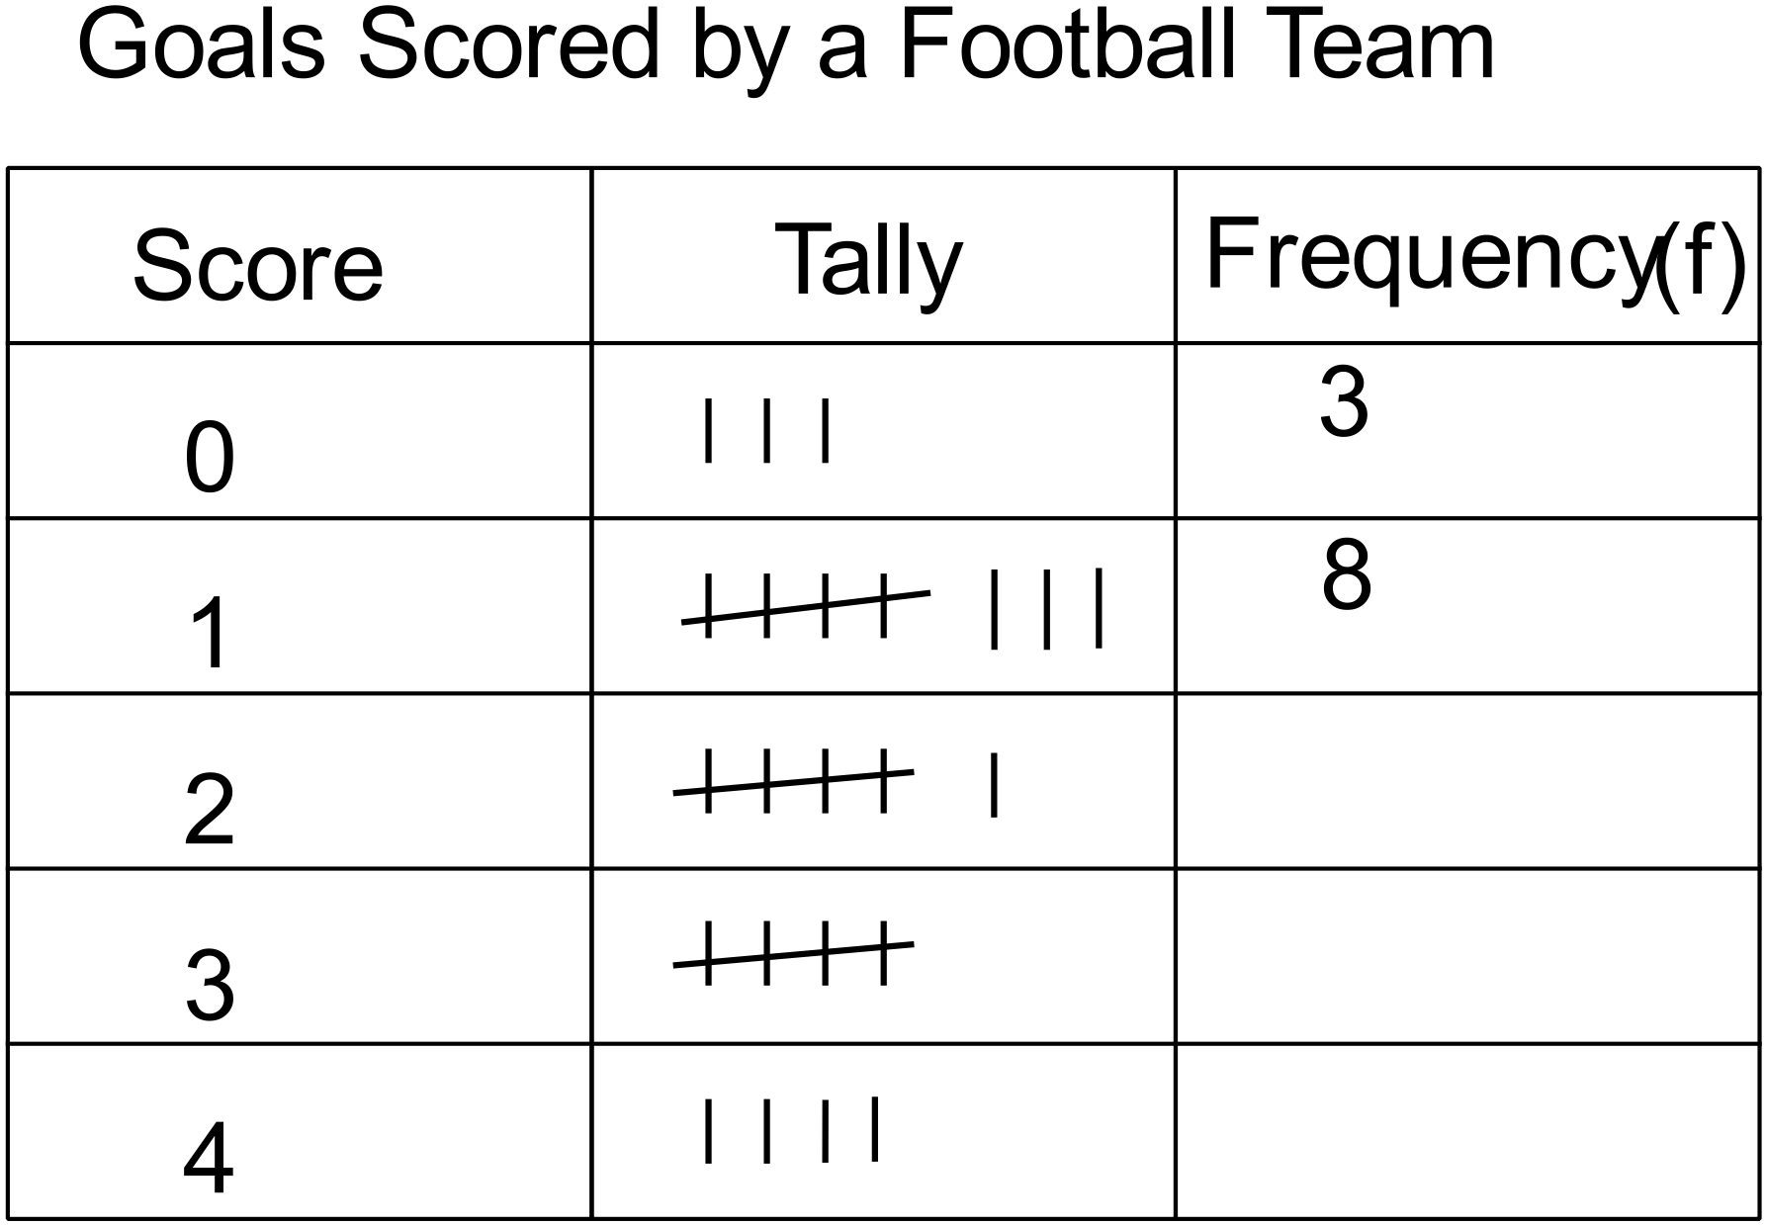

 | (a) Complete the table above. | 1
 | (b) On the grid below, draw a frequency histogram and polygon for the data.  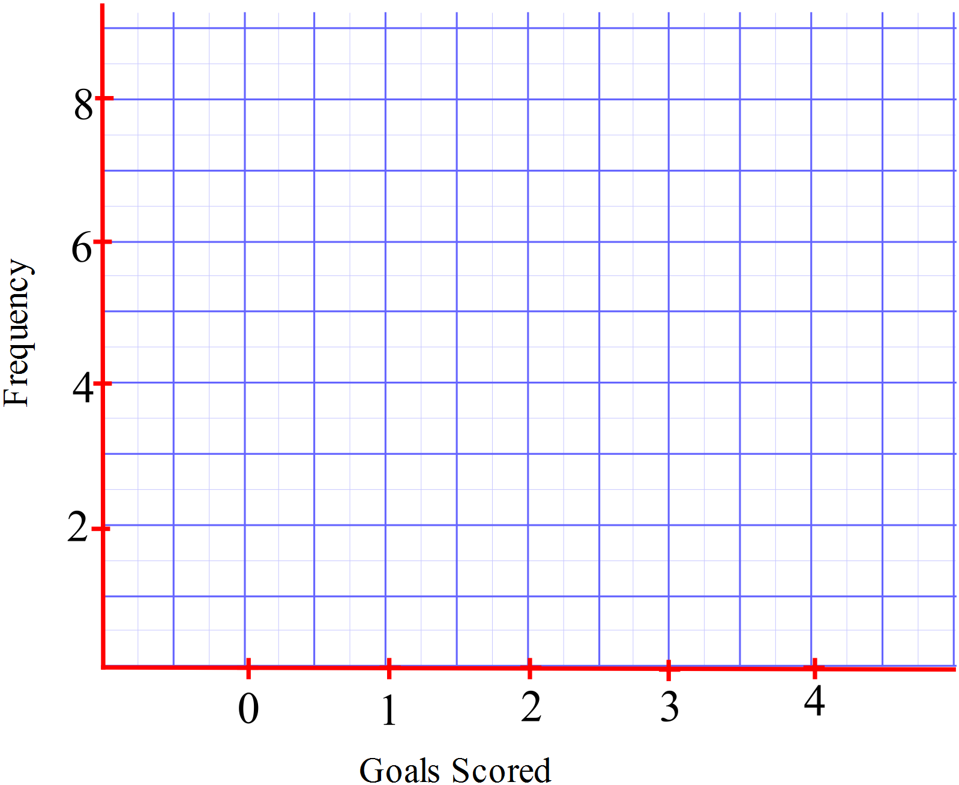 | 3
Roger's tennis coach records the number of shots that he plays in each game of a warm up match. The results are shown below.

15 | 4 | 6 | 12 | 22
18 | 33 | 24 | 15 | 23
23 | 29 | 34 | 45 | 32
12 | 11 | 23 | 8 | 25

 | (a) Compile the data above into a stem and leaf plot. | 2
  Stem | Leaves
  0
  1
  2
  3
  4
 | (b) Would you describe the distribution of scores as being symmetric? Explain your answer.  ……………………………………………………………………………………..  …………………………………………………………………………………….. | 1
 | (c) What is the range of the scores? (The difference between the highest and lowest scores.)  ……………………………………………………………………………………..  …………………………………………………………………………………….. | 1

Data Collection and Representation
ANSWERS

Non Calculator Section (1 mark each)

Raj asks every third person in his scout troupe to write down their age on a piece of paper, which he collects and records.

He is:

Collecting data by taking a census of the troupe.

Collecting data by taking a sample of the troupe.

Collecting data by observation.

Collecting data by measurement.

Jordan does a survey by asking his classmates what brand of smart phone they use.

This is an example of:

Categorical Data. Continuous Numerical Data.

Discrete Numerical Data. Observed Data.

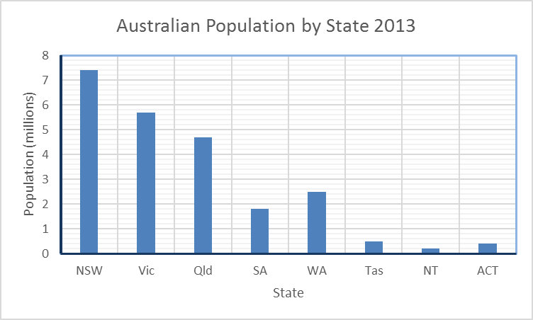

Questions 3 – 6 refer to the graph above.
What was the population of Victoria in 2013?

57 000 570 000 5 700 000 57 000 000

Which State had a population of two and a half million people in 2013?
Western Australia

Which state had the smallest population?

(NB. NT and ACT are not states.)
Tasmania

Which state had a population about of that of NSW?

Qld. SA. Vic. WA.

Nikita draws a line graph showing the room temperature over a period of 6 hours.

This is an example of:

Categorical Data. Continuous Numerical Data.

Discrete Numerical Data. Observed Data.

Number of Books Read in the Last 6 Months from a Sample of People

 |  |  |  |  |  |  |  |  | Ο
 |  |  |  | Ο |  |  |  |  | Ο | Ο
 |  | Ο |  | Ο |  |  |  | Ο | Ο | Ο
 |  | Ο | Ο | Ο | Ο |  | Ο | Ο | Ο | Ο
 | Ο | Ο | Ο | Ο | Ο |  | Ο | Ο | Ο | Ο
Ο | Ο | Ο | Ο | Ο | Ο | Ο | Ο | Ο | Ο | Ο
Ο | Ο | Ο | Ο | Ο | Ο | Ο | Ο | Ο | Ο | Ο
0 | 1 | 2 | 3 | 4 | 5 | 6 | 7 | 8 | 9 | 10 or more
 |  |  | Number of Books

Questions 8 – 11 refer to the dot plot above.
How many people read 4 books?

6 7 8 9

How many people read 8 books or more?
18

How many people were included in the sample?

7 10 46 48

Zahra said "There were four others who read the same number of books as I did".

How many books did Zahra read?

Either 2 or 8. Either 2 or 10. Either 4 or 8. Either 4 or 10.

Questions 12 – 15 refer to the graph above.
Which language made up about a quarter of the speakers?
Graph is 16 cm, Vietnamese is 4 cm, so about a quarter.

Cantonese Greek Mandarin Vietnamese

Which language had the same number of speakers as Cantonese? (both about 1.5 cm)
Italian

Greek was spoken by what fraction of the speakers?
1
5

What percentage of the speakers spoke Mandarin?
15%

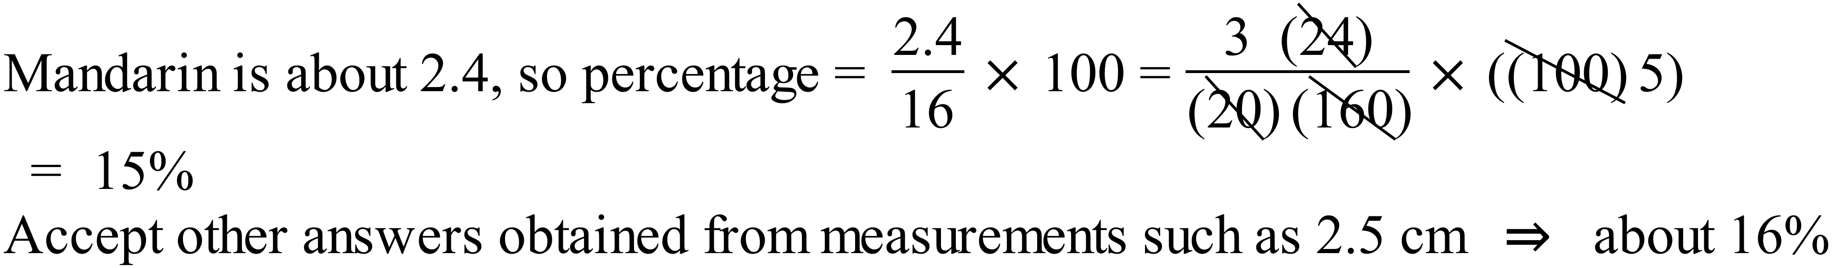

There were 400 speakers of Languages other than English at the school.

How many spoke Greek?
80
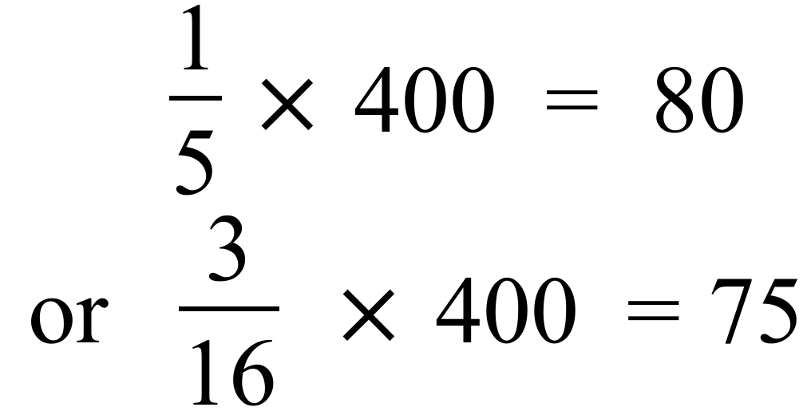

Calculator Allowed Short Answer Section (1 mark each)

Which of the following is an example of using observation as a data collection method?

A company asks all of its shareholders fill in a voting form to decide on a proposal.

A doctor measures the mass of all of his patients.

A magazine rings every person on its subscribers list.

A researcher counts how many people passing his office are wearing a tie.

Shreya asked her classmates their favourite recording artist.

Which of these graphs would not be appropriate to represent this data?

Column Graph. Divided bar Graph.

Line Graph. Sector Graph.

Questions 3 – 6 refer to the graph above.
What is the temperature at 6 pm?
8
º C

At what times is the temperature 19ºC?

1 am and 5 pm 1 pm and 4 pm 1 pm and 5 pm 2 pm and 5 pm

The temperature range is the difference between the maximum and minimum temperatures.
What is the temperature range for the day?
22

During the day a cold change came through Dunromin, and the temperatures dropped suddenly.

Between what times did the cold change arrive?

2 pm and 3 pm 3 pm and 4 pm 4 pm and 5 pm 5 pm and 6 pm

Which of the following is an example of obtaining an unbiased random sample of employees from an engineering business which employs 450 people?

Choosing every fifth male in the welding section.

Choosing every fifth employee in the welding section.

Choosing every fifth male and every fifth female employee from each section of the company.

Choosing every fifth employee from each section of the company.

Runs Scored by members of a T20 Cricket Team

Stem | Leaf
0 | 3 | 4 | 5 | 6 | 8
1 | 3 | 4 | 5 | 6 | 7 | 9
2 | 0 | 0 | 3 | 3 | 7 | 8 | 9
3 | 6 | 8 | 9 | 9
4 | 0 | 0 | 0 | 5 | 7
5 | 0 | 5 | 7
6 | 3

Questions 8 – 11 refer to the graph above.
What score was most common? (i.e. scored more times than any other score)

40

How many scores were 40 or more?

4 6 8 9

How many times was 20 runs scored?

Twice

What is the difference between the highest and lowest scores?

60 61 62 63

A manufacturer wants to find out what customers think of its new product.

Which of these surveys uses a biased sample to collect the information?

The manufacturer rings every 20th customer on an alphabetical list.

The manufacturer posts a survey form to every 10th customer on an alphabetical list.

The manufacturer posts a survey form to every customer who lives in a certain suburb.

The manufacturer rings all customers who have a vowel as the first letter of their name.

Questions 13 – 16 refer to the graph above.
What fraction of car sales were from Victoria?

What percentage of sales were from NSW?

30
%

There were 1.2 million cars sold in Australia in 2013.

How many were sold in Qld?

120 000 240 000 360 000 480 000

How many more cars were sold in Qld compared to WA?

120 000
cars.

Calculator Allowed Longer Answer Section (1 mark each)

Warren compiled the frequency table below.
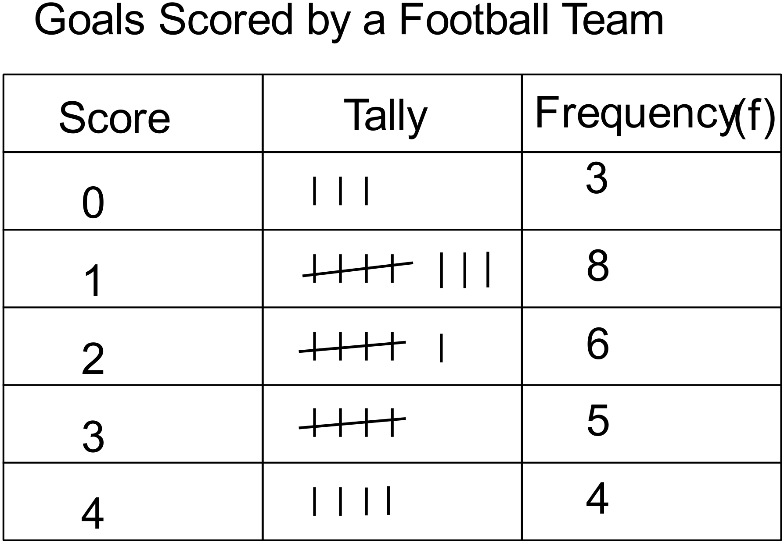

 | (a) Complete the table above. | 1
 | (b) On the grid below, draw a frequency histogram and polygon for the data.  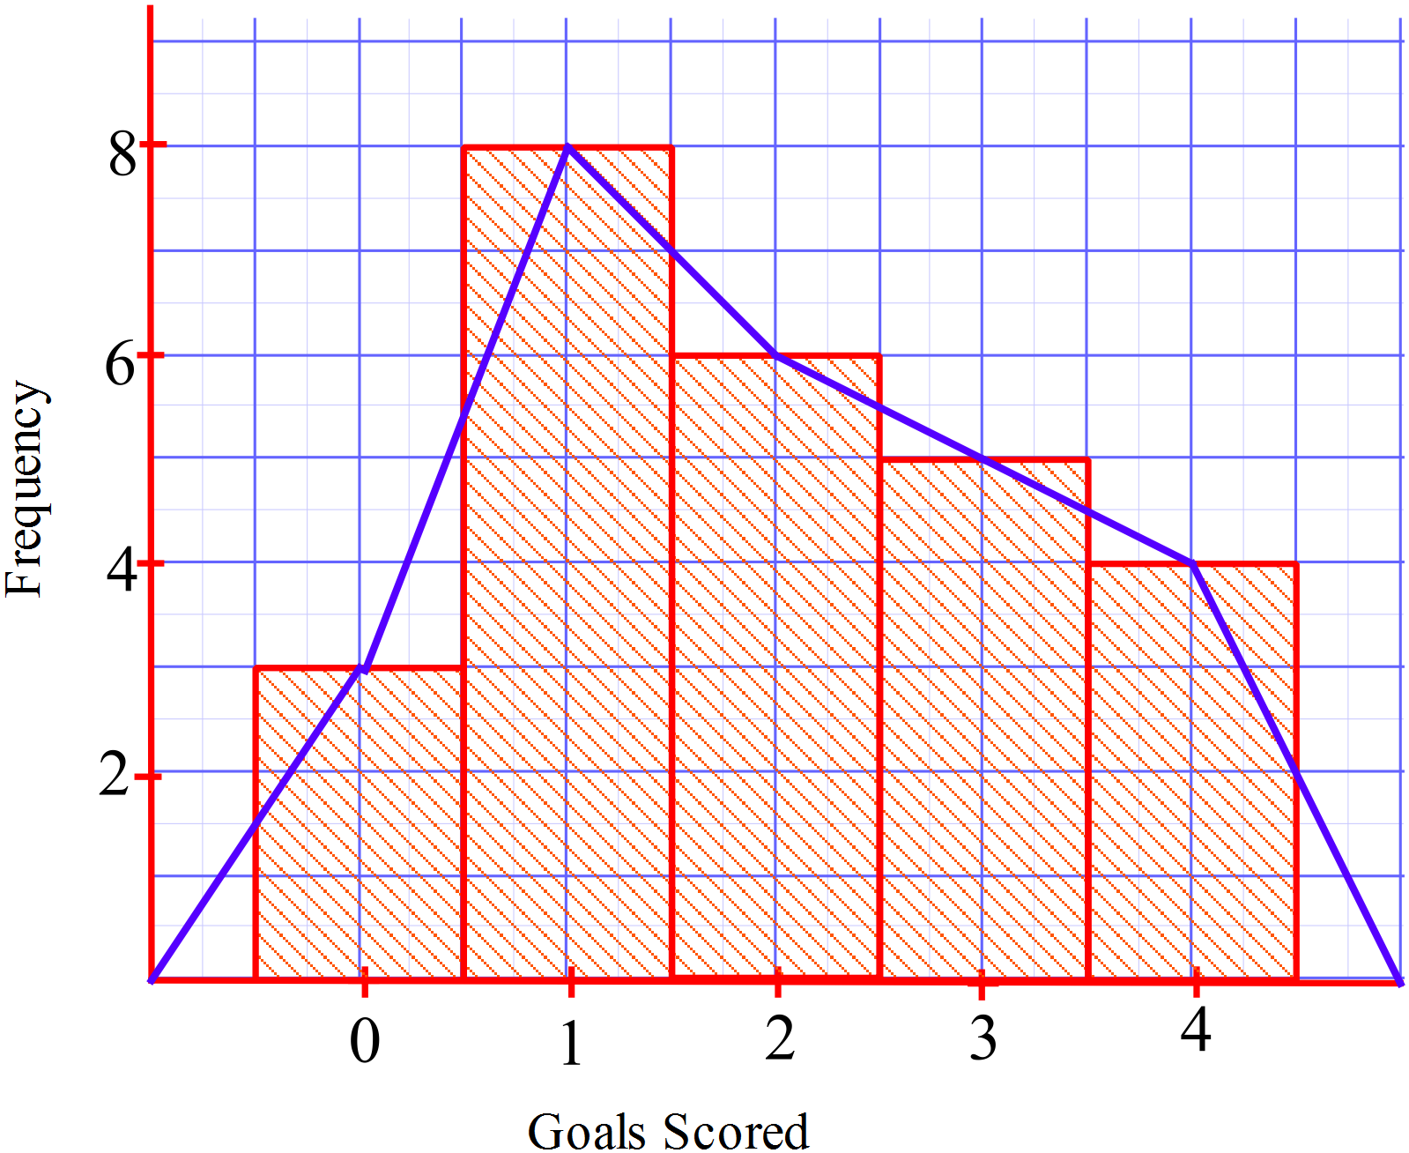 | 3
Roger's tennis coach records the number of shots that he plays in each game of a warm up match. The results are shown below.

15 | 4 | 6 | 12 | 22
18 | 33 | 24 | 15 | 23
23 | 29 | 34 | 45 | 32
12 | 11 | 23 | 8 | 25

 | (a) Compile the data above into a stem and leaf plot. | 2
  Stem | Leaves
  0 | 4 | 6 | 8
  1 | 5 | 2 | 8 | 5 | 2 | 1
  2 | 2 | 4 | 3 | 3 | 9 | 3 | 5
  3 | 3 | 4 | 2
  4 | 5
 | (b) Would you describe the distribution of scores as being symmetric? Explain your answer.  No it isn’t symmetric. There are more scores in the lower part of the distribution. | 1
 | (c) What is the range of the scores? (The difference between the highest and lowest scores.)  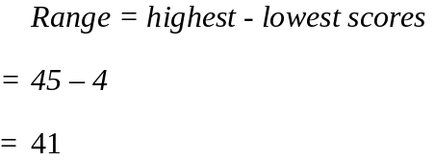 | 1

